**A World of water**

Water is essential to life and we depend on it, yet many people take water for granted. As the population of the world increases, and with it the demand for water, there is growing concern that our water supplies will not prove adequate. In areas near the coast, an obvious solution to this problem is to find ways of utilizing the abundant supply of water from the sea.

Water covers 70% of the surface of the earth, but 98% of this is undrinkable salt water. However, for centuries man has experimented with different methods of covering salt water into fresh water in a process called desalination, whereby salt and contaminants are removed from the water. The challenge, nowadays, is to do this on a much larger scale.

One place which has used desalination for many years is the United Arab Emirates. It installed the first desalination plants in 1972, and nowadays most of the drinking water in the country is supplied by this process. New filtration systems have been developed to replace the traditional methods, which used a heating process. Another example is Saudi Arabia, whose desalination plants produce almost 25% of the world’s desalinated water. One of the largest plants in the world has been constructed there, producing 300 billion litres annually.

China, with its rapid industrial growth, has also experiences an increased demand for water as well as energy. To overcome the shortage of both, China built a combined power and desalination plant in Zhejiang province in the 1970s. Since then, salt water has been taken from the East China Sea and converted into fresh water. Some of this fresh water is then sold to industry, some is used in the production of energy, and the remainder is sold as drinking water.

Unfortunately, desalination is an expensive process using large amounts of energy, but research is currently being carried out into the development of more efficient technology using a combination of different methods. To supply water to 25% of the world’s population living within 25 kilometers of the sea, more desalination plants are expected to be built in the future. The hope is that the technology currently being developed will lower the costs and help solve the problem of water shortages in many parts of the world.

Source: Headway Academic Skills reading, writing, and study skills level 3

1.the method of covering salt water into fresh water

2. salt

3. Thermal process, membrane processes

4. China, Arabs, Saudi Arabia

5. 1970

6. Generate electricity

7. 1960

8. the population of the world increases, and with it the demand for water increases (ประชากรโลกเพิ่มขึ้น และความต้องการน้ำก็เพิ่มขึ้นด้วย)

9. สร้างโรงแยกเกลือเพิ่มมากขึ้น เพื่อที่จะได้ใช้น้ำจากน้ำทะเลได้มากขึ้น

10. สร้างโรงแยกเกลือเพิ่มเพื่อให้สามารถจัดการได้มากขึ้น และหวังว่าเทคโนโลยีที่กำลังพัฒนาในปัจจุบันจะช่วยลดต้นทุนได้ (Build more desalination plants to make them more manageable and the hope is that the technology currently being developed will lower the costs.)

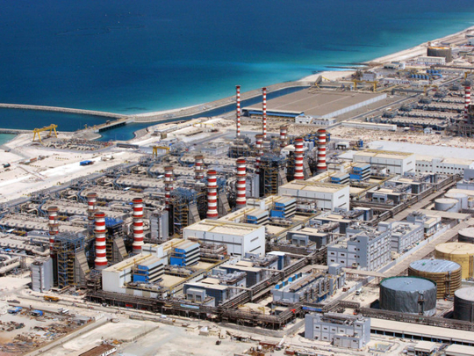

Figure 1 desalination plant in UAE